**Nama : Aldi Septiyanto**

**NIM : 20210140002**

**Kelas : A**

**Matkul : Pengembangan Desain Web**

**PRAKTIKUM 7 PDW**

**Nb. Code index.html**

***Nb. Code style.css***

***Nb. Code form.html***

***Nb. Code form.css***

***Nb. Code about_me.html***

***Nb. Code about_me.css***

***Nb. Run Code***

***Apabila di tekan kontak di bawah langsung ke instagram.***

***Nb. Form.***

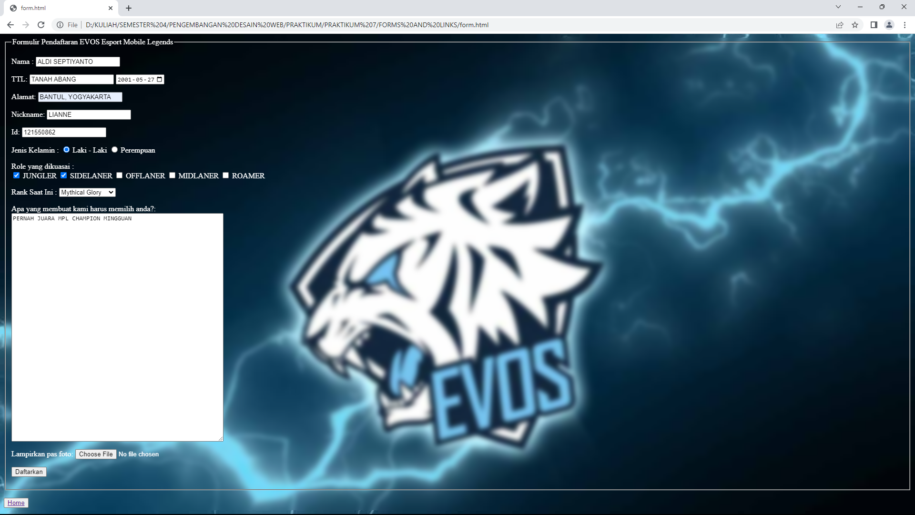

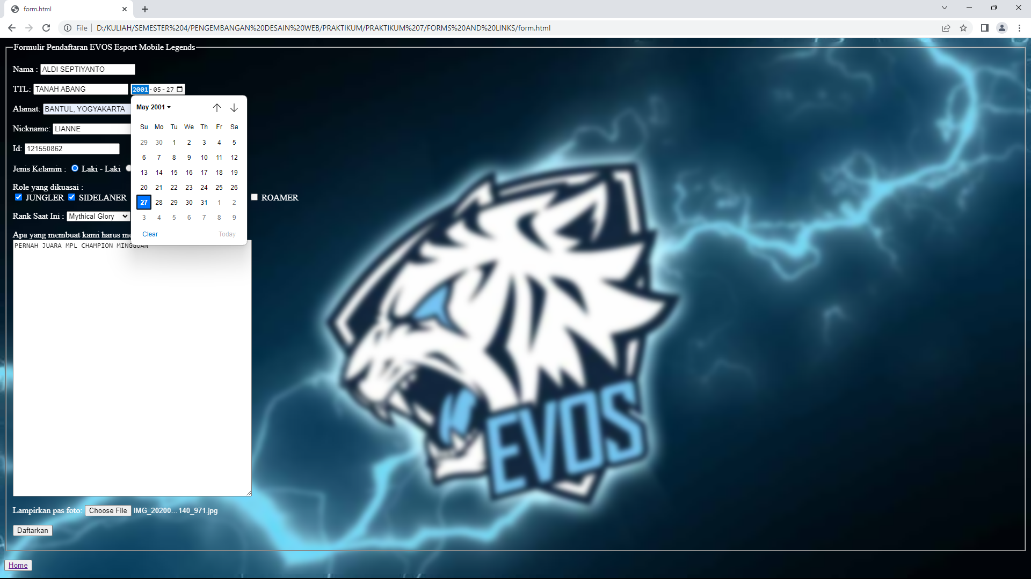

***Nb. About.***